|  |
| --- |
|  |
| #ASKOTEC  Packing and unpacking of #ASKOTEC |
| |  |  |  | | --- | --- | --- | |  | 5/28/18 |  | |

GUIDE FOR PACKING AND UN PACKING OF #ASKOTEC KIT:

**THE FIRST LAYER:**

1. Place the case on a table. 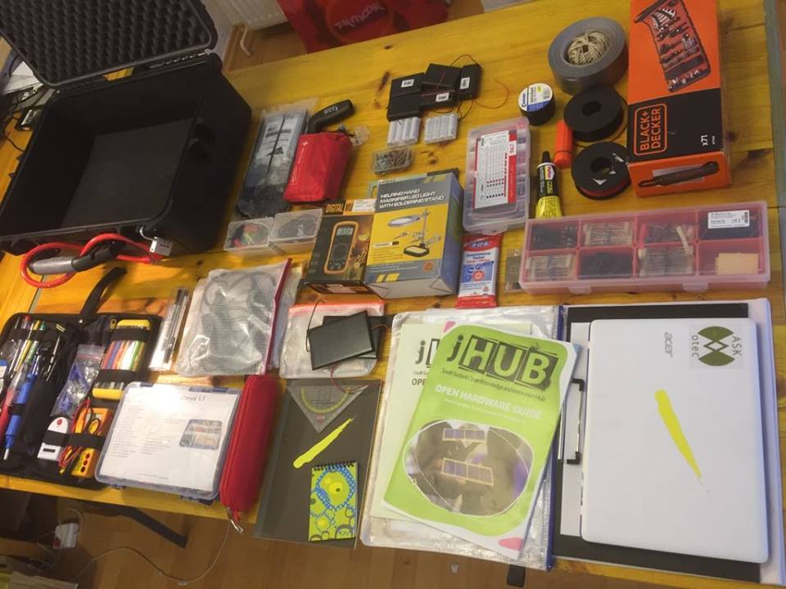
2. Put the black and decker kit on the right hand corner of the case.
3. Saw goes on the left corner of the case and then we put the zip ties pack on the top of it and blade should face the wall of the case for a safe sight.
4. Next to the black and decker kit we place the tape and black and red wire.
5. With the back wall we put the isolating tape with batteries and their cases that covers the center of the case.
6. The round battery pack with the back wall of the case and nails also in the center.
7. Near the front wall in the center we put helping hand kit and in the standing position with the front wall we place multimeter and in the gap small red match box.
8. In the round corner with the black and decker kit we place solded solar panels.
9. On the top of zip ties bag in the left top corner we put circuit boards in orange zip lock bag.
10. On the top of the battery case is cleaning pad and in the middle next to the

Helping hand kit is compass box and the box also has extra blades for the saw it.

First layer is done.

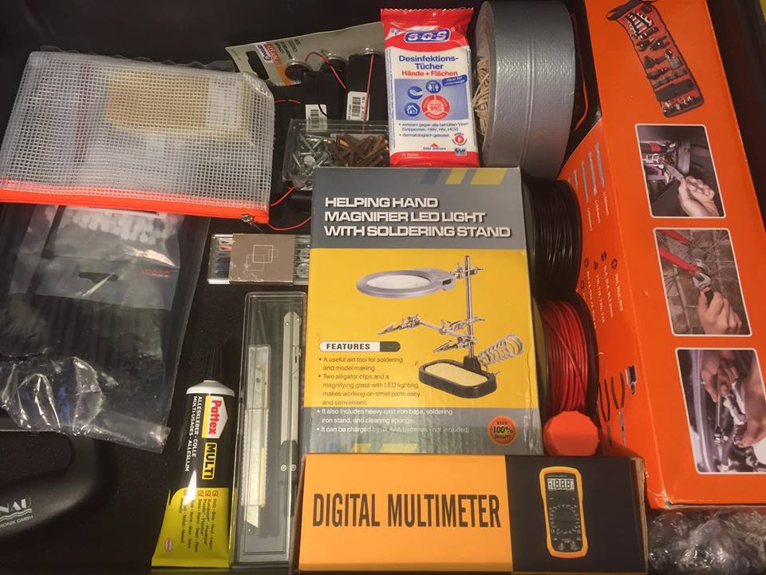

**Layer no Two:**

1. In the second layer the aurdino kit goes in the left corner on the top of range zip bag.
2. In the middle on the top of helping hand kit we put shrink tube box.
3. In the front most corner on the left goes plastic container with extra stuff.

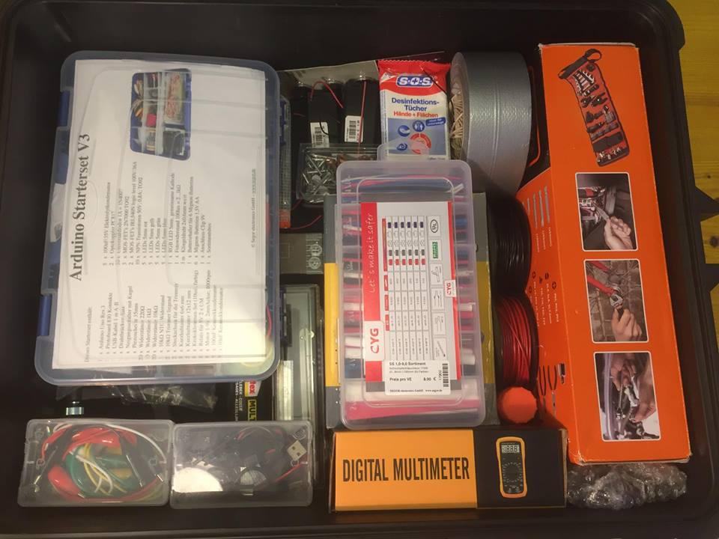

**Layer no third:**

1. Soldering and fixing kit goes on the top of the aurdino kit, in the left side with back facing the wall of the case.
2. The yellow zip bag on the top of the shrink tube case with instructions pages and small plastic stuff.
3. The first aid kit in the back side of the case goes on the top of the battery, and there is a small hole next to the first aid kit where we keep travel adapter.
4. The red zip bag with the charger goes on the top of yellow zip bag.
5. Then the pencil case goes in the front left corner in a small space and beneath this we keep swing kit and calculator in fixed standing position scissor next to it.

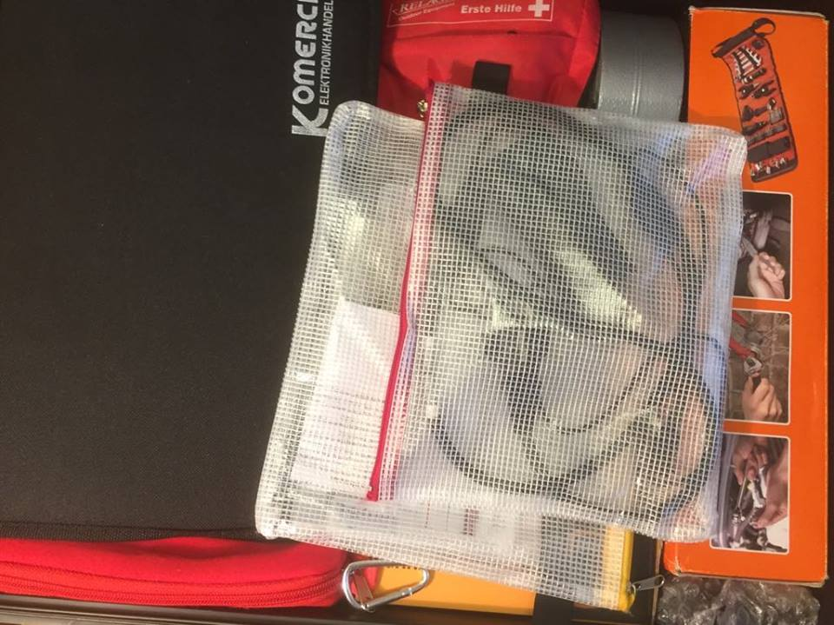

**The final layer:**

1. Red and white plastic container with small electronic stuff goes in the right side of the case.
2. On the top of the soldering kit we put laptop.
3. In the middle we put clipboard with clip side facing the electronic box upside down.
4. 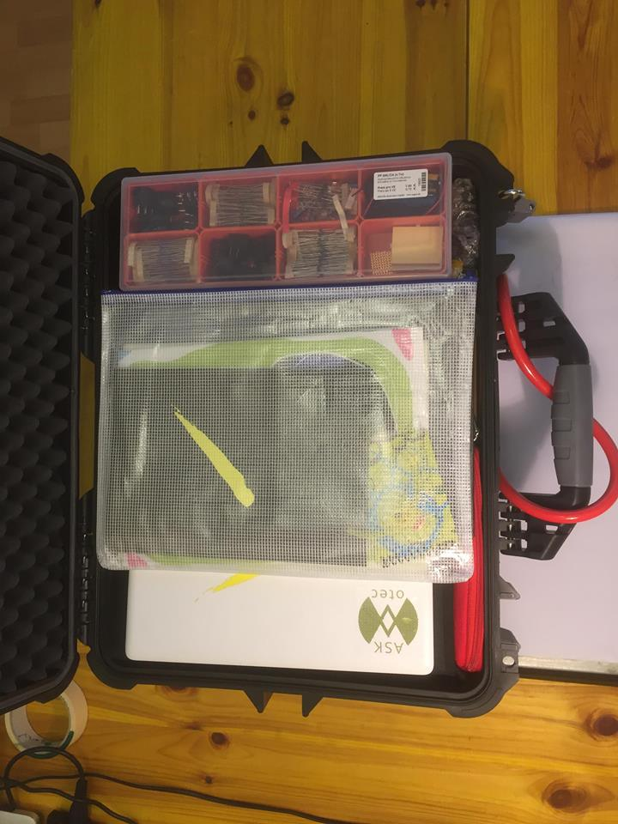The blue zip bag with all the books and reading material and the square ruler, goes on the top in the middle and the case is now packed.